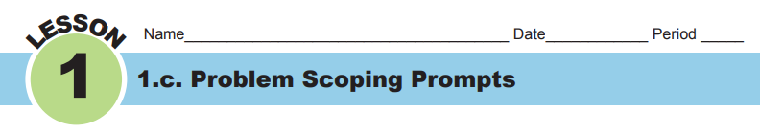First, on your own, answer each of the following questions beside the “My Response” space. Then, in your teams, each person is to share their response and discuss. In the space “Team Response,” write your revised answer to the question, based on discussion with your team. You may use a different color writing utensil to distinguish your answer and how it changed after talking with teammates.

- Who is the client?
My response:

Team response:

- What is the client’s problem that needs a solution?
My response:

Team response:

- Why is the problem important to solve?
My response:

Team response:
- Who are the end-users?
My response:
Team response:

- What will make a solution effective (criteria)?
My response:

Team response:

- What will limit how you can solve the problem (constraints)?
My response:

Team response:

- Think about the problem of minerals spilled into a lake. In terms of sorting the minerals, what do you need to learn in order to create procedures to separate the minerals?

My response:

Team response:

