Falling Things Lab
Stations will be set up around the room. You will have 2 minutes at each station, during which time you will be dropping objects from higher and higher heights and observing what happens. Record your observations for each station and then try to make a generalization about what happens to the speed of objects as they fall based on you observations.

Clay Ball Drop the clay ball onto the floor from various heights. Before each drop, roll the ball back into a round shape.
Plastic Wrap & Ball Bearing Stretch plastic wrap over the plastic cup, holding it on with the rubber band. Drop the ball bearing onto the plastic wrap from gradually increasing heights.
Ink Drops Using the dropper, squeeze drops of ink onto the paper from various heights, beginning at about 1 cm.
Ball Bounce Drop a tennis ball from various heights.
Scissors & Play Doh Release the scissors from various heights, smoothing out Play-Doh before each drop.
Ball Bearing on Ramp Roll the ball bearing off the ramp and onto the floor, using a block of wood to raise the plastic track to various heights.
Ball Sounds Drop the balls from various heights and listen to the sound they make when they hit the ground.
Ball Bearing and Sand Drop the ball bearing into the container of sand from various heights
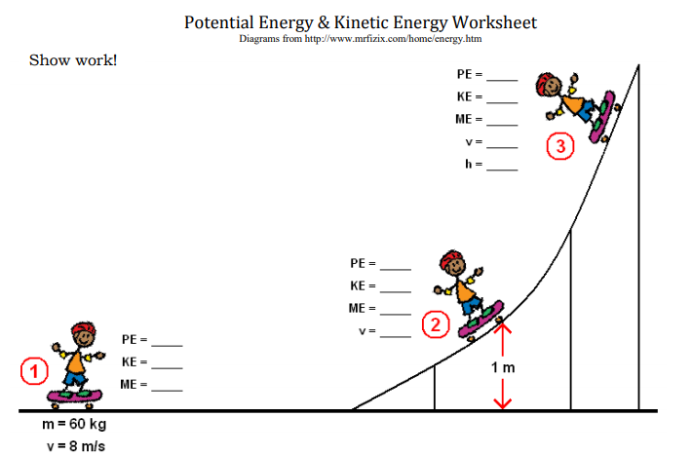
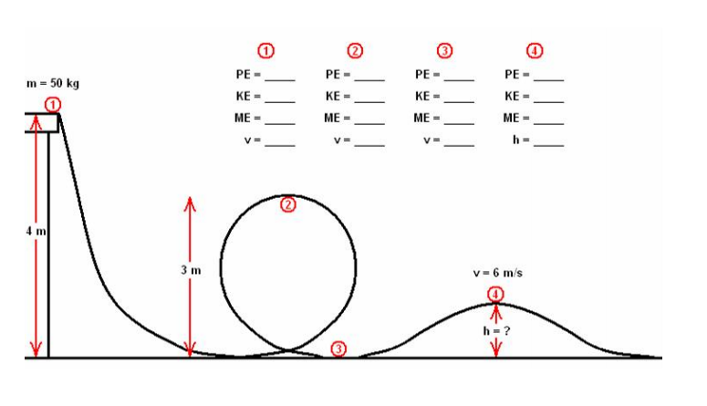
Exercises

1) If you do work on an object, does its energy change?
2) How can you increase the gravitational potential energy of an object?
3) What happens to your potential energy as you go up in an airplane? Compared to what?
4) If an object weighs 500 N and you lift it 2 m, a) how much work have you done on it?
b) how much potential energy does it have relative to its starting point?
5) If an object has 100 J of PE, how much work can it do (with that PE)? Ignore friction.
6) How much energy does a 2 kg ball sitting on a 1m high table have?
7) If a 1,000 N rock falls 10 m, how much work will it do when it hits?
8) How can you increase the kinetic energy of an object?
9) If a car is traveling at a steady speed, but you double its mass, what happens to its kinetic energy?
10) If you double a car’s speed, what happens to its kinetic energy?
11) When you throw a ball up in the air, when is its kinetic energy greatest? When is its potential energy greatest? Explain.
12) Draw a picture of a 20 N rock falling from a 100 m high cliff. Give its PE and KE when it is 100 m high, 75 m, 50 m, 25 m, and 0 m. Ignore air resistance.
13) Galileo (supposedly) dropped two balls from the leaning tower of Pisa. If the bigger ball had twice the mass of the smaller one, what was its KE compared to the smaller one just before they hit?
14) By what factor does the KE of a plane change if it doubles its speed?
15) Two identical rocks are dropped from different heights. The higher one starts out four times as high as the lower one. How much faster is the higher one going just before they hit? Ignore air resistance.

