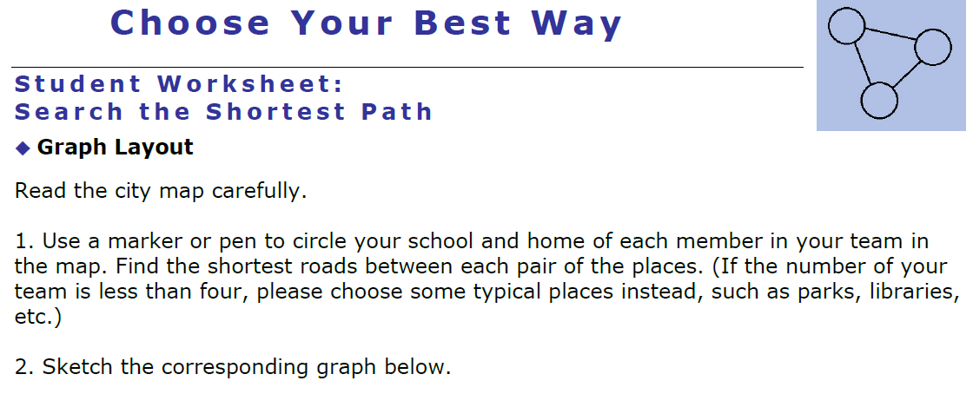

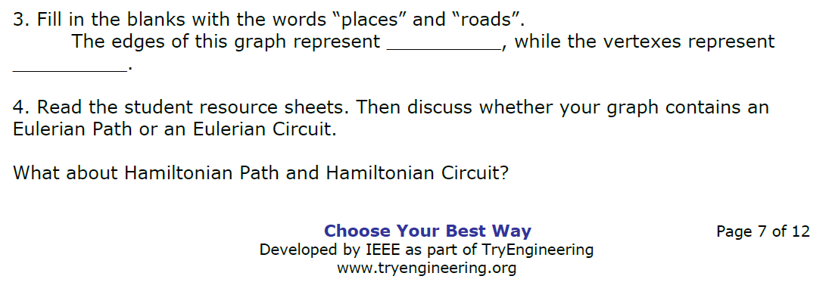
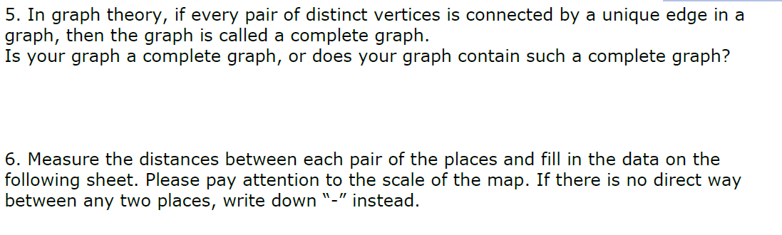
Unit of Measurement __________

Distance | School | ____’s home | ____’s home | ____’s home | ____’s home | ____’s home
School | X
____’s home |  | X
____’s home |  |  | X
____’s home |  |  |  | X
____’s home |  |  |  |  | X
____’s home |  |  |  |  |  | X

