NAME:
Draw (in plan view) the earth’s position in relation to the sun during the following four times of the year. Indicate the appropriate direction of axial tilt and label with the correct Julian Day:
- June 22 (Summer Solstice) Julian Day: __________
- September 23 (Autumnal Equinox) Julian Day: __________
- December 22 (Winter Solstice) Julian Day: __________
- March 21 (Vernal Equinox) Julian Day: __________
Additionally, indicate the Earths position on your birthday and calculate the Julian Day!
Earth’s Orbit
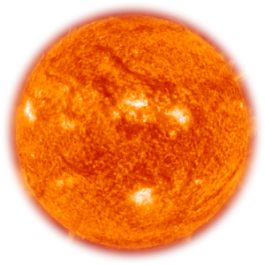

The Sun

What is the date of your birthday? _________________________
What is the Julian Day (of your Birthday)? ___________________

